CYB102 Prework (🔗 Instructions Page)

👤 Student Name: Shireen M
✉️ Student Email:

Part 1: Bash-ing Your Way to Success (Required)

See the 🔗Instructions Page for detailed instructions on completing Part 1. Once you’re done, come back here and add in your screenshot.

Challenge #1:
echo "Hi, my name is Shireen. I am a Master in Computer Science student now gaining some knowledge about Cybersecurity,Linux and bash scripting to apply for internship." > intro.txt
Challenge #2:
chmod a-w permanent.txt
Challenge #3:
cp random.txt copy.txt
Screenshot #1: Your screenshot of the ✅ Challenge X Complete! and 🎉 CYB102 Prework complete! 🎉 messages in your terminal.
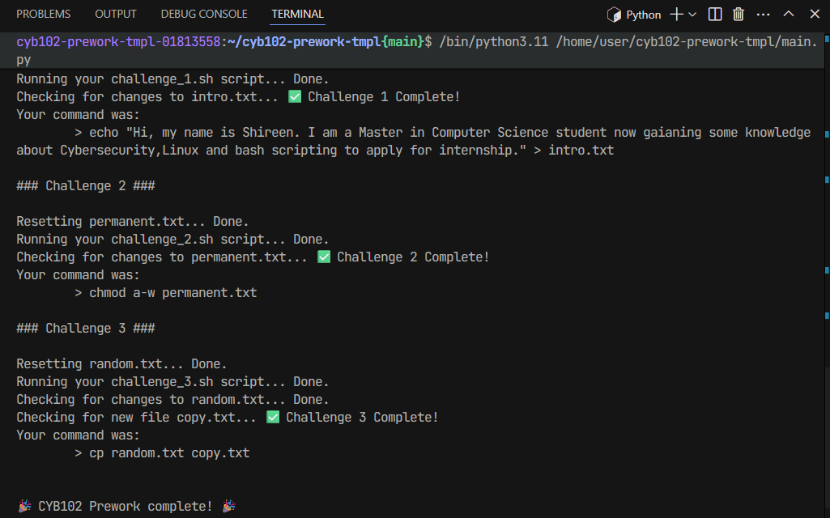
Notes (Optional):

Part 2: Thinking Like a Blue Teamer (Required)

For this part, you’re going to be challenged to start thinking about computing from a blue team perspective. Don’t worry, there are no “right answers” to these questions – it’s just to get you thinking! Use your search engines and explore!

The Scenario
On a sunny afternoon, the employees of Happy Hippo Co., a small toy manufacturer, returned to their desks to find that they were unable to access any of their files. A message had popped up on their screens, demanding payment of 50 bitcoins, in exchange for the decryption key of their critical data that had been encrypted by a ransomware attack.

The message read, “Your files have been encrypted and are no longer accessible. Please follow the instructions below to obtain the decryption key. Payment must be made within 72 hours, or the decryption key will be permanently deleted.”

The IT team at Happy Hippo Co. quickly realized that their server had been attacked by ransomware, which had resulted in the encryption of critical data. The team tried to isolate the affected system, but it was too late, as the ransomware had already spread to all other systems on the network.

The CEO of Happy Hippo Co. contacted a friend, Bob the White Hat Hacker, who was a cybersecurity expert. Bob quickly analyzed the situation and provided a report stating that the ransomware attack was caused due to an employee clicking on a phishing email, which allowed the attacker to gain unauthorized access to the company’s network.

Bob also stated that the encryption used by the attacker was a strong one which used RSA-2048 encryption. He advised the company to not pay the attackers and instead to restore data from their backups.

The IT team quickly restored the data, which had been backed up regularly, and Happy Hippo Co. was back to business in no time.

Scenario Questions (Required)
❓ Question #1: What cybersecurity measures can Happy Hippo Co. implement to mitigate the risk of future ransomware attacks? (100+ words)
After reading what happened to Happy Hippo Co, it's so obvious that they need a stronger defenses system in place before any attack happened in their company. First and most easy option will be to make sure all their software and operating systems are kept up to date it shown in many cybersecurity articles that a lot of ransomware attack happens due to known vulnerabilities. Second will be that they should also invest in a good antivirus and endpoint detection tool that can catch suspicious activity early. Another big one is network segmentation basically dividing the network into smaller sections so that if one part gets infected, it can't easily spread everywhere like it did here. Last one will be the Multi-factor authentication (MFA) is another must-have which are being using by almost every company and even now social media has that option too, it protects even if an attacker gets a password, they still can't get in without a second verification step. And of course, as I come from a Database Administration background I am very well aware of the importance of the backups keeping regular, tested backups stored offline or in a separate secure location is needed at this point to save Happy Hippo Co. Without those backups, they would have been in serious trouble. Having a proper incident response plan ready before anything happens would also help the team react faster and smarter next time instead of scrambling.

❓ Question #2: What policies and procedures should be put in place to educate the Happy Hippo Co. employees on the dangers of phishing emails? (100+ words)
As mentioned in the given scenario that this whole attack started because one employee clicked on a phishing email, from this we understand that employee education about phishing and different sorts of attacks is honestly the most important thing Happy Hippo Co. needs to avoid this issue to occur in future. A lot of people just don't know what a phishing email looks like, especially the more convincing ones that pretend to be from a real company or even a coworker and sometime we don't pay attention to the details which we know that is a scam or phishing email we end up clicking those. The company should introduce mandatory regular security awareness training to take this training every six months so people stay sharp. They should also run simulated phishing tests where IT sends fake phishing emails to employees to see who clicks and then follows up with training for those who do. There should be a clear and easy way for employees to report suspicious emails without feeling embarrassed about it, like a dedicated button in their email client or a simple email address to forward it to, as we see in many organizations they have reported phishing or scam emails in outlook. The company should also have a written policy explaining what employees should and should not click on, what to do if they think they made a mistake, and what the consequences are for ignoring security rules. Making security feel like a team effort rather than just an IT problem goes a long way.

❓ Question #3: How can an organization like Happy Hippo Co. quickly isolate systems that are affected to prevent the spread of ransomware attacks? (100+ words)
One of the hardest lessons from this scenario is that, by the time the IT team tried to isolate the affected system the ransomware had already spread to every other system on the network. That tells me they probably didn’t have fast enough detection or isolation procedures ready to go like right there when it mattered. The first thing they should set up is network segmentation so different departments or systems live on separate parts of the network. That way ransomware can’t just wander freely and jump from one machine to another as if nothing was blocking it. They should also have automated detection tools that can flag odd behavior for instance a system suddenly encrypting a massive number of files and then automatically disconnect that device from the network before waiting for a human to notice. It also sounds like they need a written playbook, specifically for ransomware incidents so the IT team knows exactly what to do and in what order like disconnecting the infected machines from the network immediately. They should disable Wi‑Fi and Bluetooth on the affected devices too and notify management right away not after a long figuring out period.Training matters as well because the sooner the team can spot early warning signs of ransomware the better their chances. Things like unusual file access patterns or weird CPU spikes should be treated like an alarm bell not background noise. Honestly speed is everything in containment every second the ransomware keeps running it encrypts more files and spreads further.

Nice job, that’s everything for the prework!

Submission Checklist
👉Check off each of the features you have completed. You will only be graded on the features you check off.

Part 1: Challenge Screenshots
- Challenge #1 Command
- Challenge #2 Command
- Challenge #3 Command
- Screenshot of success message

Part 2: Scenario Questions
- Question #1 answered above (100+ words)
- Question #2 answered above (100+ words)
- Question #3 answered above (100+ words)

